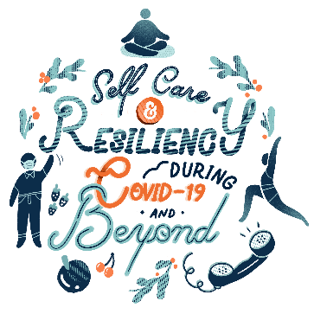
Providence NWWA
Caregiver Self-Care & Resiliency Health Fair
January 28, 2021 – 7AM Agenda

Moderator Kick-off & Introduction
Jessica Burt, Director of Equity & Caregiver Well-Being/NWSA | Director of Program Operations/PIHC

Breast Center
- Topic: Are You at High Risk for Breast Cancer?
Presenter: Erin Chaney, Nurse Practitioner
Injury Prevention
- Topic: Inside Out Program & Impact Teen Driver Program
Presenter: Rachel Weiding-Marty, Community Outreach Educator
- Topic: Stop the Bleed
Presenter: Miklos (Mik) Preysz, Clinical Data Trauma Analyst
- Topic: Fall Prevention
Presenter: Shanie McLaren, Community Health Educator
Mission and Spirtual Care
- Topic: Sustaining Your Spirit – Ways to Go In and Look Up
Presenter: Barry Stueve, Chief Mission Integration Officer
Stroke (Neuroscience Department)
- Topic: Heart and Brain Wellness- Making healthy Choices!
Presenter: Lisa Shumaker, RN, Stroke Program Coordinator
PSJH Community Partnerships
- Topic: Work2BeWell: Mental Health & Wellness Resources for Caregivers and our Community
Presenters: Kayla Keigley, Director Work2BeWell and Regina Fernandez, Project Coordinator Work2BeWell // Community Partnerships
Providence Medical Group (PMG), Behavioral Health
- Topic: Guided Practice for Mindfulness
Presenter: Crystal Blankinship, Manager of Behavioral Health, Providence Medical Group
Providence Institute for a Healthier Community and Diversity/Well-being Committee
- Topic: Understanding Your Worth
Presenter: Kaila Alvarez, Diversity, Equity & Inclusion Manager, NWSA
- Topic: Accessing Community Well-Being Resources
Presenter: Jessica Stallings, Community Health Education Manager, PIHC
- Topic: Values, Beliefs and Money
Presenter: Work Source NWWA Providence Financial Video Series Preview
Providence Intervention Center for Assault and Abuse
- Topic: PICAA Services and Sex Trafficking Awareness
Presenters: Carie Sattler, Advocate Specialist and Susanna Wren, Advocate Specialist & Volunteer Coordinator
Providence Regional Medical Center (PRMCE)
- Topic: How to Maintain Your Brain
Presenter: Kevin Clay, Exec Dir Ambulatory Medicine, Physician Leadership

